|  |  |
| --- | --- |
| My Wardrobe  An online website that allows customers to design and order their suit of choice and view it on a 3D model | SOFTWARE DOCUMENT |

Abstract

The purpose of this document is to provide an analysis about the successfully completed project. The purpose of my project is to allow customers to have an excellent experience of online shopping by viewing their selected designs on a 3D model and the organization(vendors) a better approach to maintain their online store. The motivation of developing this project was the difficulty for customers to visualize how their selected suit design would look on a real person even before buying or ordering the suit. The users would be able to view their designed suit on a model and save, edit or delete them as required, as every user would have his own profile, they can always come back and update their saved measurements and/or update their designs. The website has separate portals for the users/customers and the vendors so that they can view orders process them and other features.

Table of Contents

1. Introduction 4

2. Background 5

3. Project Scope 6

4. Software process model 7

5. Project Schedule 8

6. Project Design 9

6.1 System Use Cases 12

6.2 System Activity Diagram 13

7. Tools and Techniques 15

7.1 My SQL 15

7.2 Dreamweaver 15

7.3 PHP 15

7.4 Bootstrap 15

8. Implemented Interface 16

8.1 My Wardrobe: Customer portal 16

8.2 My Wardrobe: Admin portal 24

9. Future Development 26

10. Conclusions 26

Table of Figures

Figure 1: Project schedule 8

Figure 2: Gantt Chart 8

Figure 3 use case diagram 12

Figure 4: Activity diagram (Customer) 13

Figure 5: Activity Diagram (Administration) 14

Figure 6: My Wardrobe- Homepage 16

Figure 7: Sign In/Register page 17

Figure 8: User Dashboard 18

Figure 9: Build suit Page 18

Figure 10: Checkout Page 19

Figure 11: My Orders Page 19

Figure 12: My Measurements Page 20

Figure 13: My Wish List Page 20

Figure 14: Appointment Page 21

Figure 15: Admin Dashboard 24

Figure 16: Admin- Update User 24

Figure 17: Admin- View Order Details 25

# Introduction

Several online websites are present today that allows customers to easily go online and by the click of a mouse have the desired product delivered to their doorsteps.

This project provides interactive and user friendly website to potential users and incorporating amazing visual representations of the suit into the website bringing it to a whole other dimension.

With the creation of My Wardrobe, I plan to provide its users including admin and the customers an amazing experience of online designing and shopping. The website is easy to use and my goal is to save time and provide users with a great experience focusing on all kinds of population.

# Background

Someone in my family happens to be a traditional men's suits tailor, owning a small business to cater to his clients. As I was thinking about the topic of my upcoming project it struck me and then convinced me that I should transfer my uncle's custom tailoring business into website based online business.

Making the decision to change from traditional business model to e-business is a big step, which can lead to a great business growth if handled properly. While many of the business processes and operations remain the same, there are certain things such as operating procedures, website design, advertising, changeover etc. are important considerations in order to make online business successful.

In this project I have tried to transform the traditional suit tailoring business to occupy a niche space in the e-commerce market, offering the customers to select the fabric of their choice, the style and design of their likings finally entering their measurements by following the step-by-step guidelines. My project tries to offer the client made to measure men's suiting in the most convenient way possible. Overcoming the hurdles of cost and inconvenience often associated with traditional tailoring. It enables a custom design tailoring of men’s suits through a website, which properly guides the client to enter his measurements and then stored those measurements online. Suits can then be ordered online with payment options through credit cards etc.

Hence, this project provides a transformation of a traditional tailoring into an e-commerce for a highly innovative yet widely accessible one stop shop for men's suits selection.

There have been some websites developed for this purpose but they do not give customers a real-time experience as of how their selected design would look by 3D representation.

So the need for developing such a website emerged where the users can have that real-time experience. Also the vendors can have a better idea of what they have to prepare for their customers to give them a satisfactory experience.

# Project Scope

My Wardrobe is a website which is mainly composed of following modules:

* Online shopping
* Customer profiles
* Administration profiles
* Custom design of Suit
* Representation of suit design on a model
* Payment portal
* Customer management
* Product management
* Customer/Orders/Appointment view for vendors
* Appointment portal

The web site has separate portals for the customers as well as the company using the platform to sell their products so that they can add new products and update the relevant information.

Following are some of the main features included in the scope of the website:

### My Wardrobe: Customer’s Portal

* Customers have their own profiles, they will have to sign up and then sign in to the website.
* After that they would be given an option to start designing their suit.
* There would be a graphical figure that would show the user how to take measurements and
* then save them in their profile.
* After that the customer could select the fabric and style which would be shown on the model.
* User can save the order for later or place the order.
* Customers can also add their designs in a wish list for later.
* They can also make appointment for any reason.
* They have the ability to pay online.

### My Wardrobe: Admin Portal

* Admin has his own user name and password.
* Admin can view edit or delete the orders placed by the customers.
* After processing they can mark the order as processed and the customers would be notified in their profile.
* They can view, add or delete the users. They can also add new admin members.
* They can view or delete the appointments.

# Software process model

In order to complete the project in total of eight months’ duration, I followed the analysis, design and implementation and testing parts with thorough unit testing and integration testing, doing updates and modifications as necessary due to some vague requirements that were fulfilled later on.

I followed the incremental model of software development, which combines the linear sequential model with the iterative approach. I produced some prototypes at first for the vendors to test which had a certain part of the total project. Afterwards the final prototype was completed.

# Project Schedule

The project was released within the scheduled time frame. All key milestones and deliverables were met in the predicted time frame.

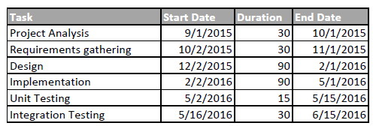

Figure : Project schedule

Phases for in my project included project analysis, requirements gathering, Design, Implementation, unit testing and then integration testing. Following is the schedule that I followed for my project completion in the form of a Gantt Chart:

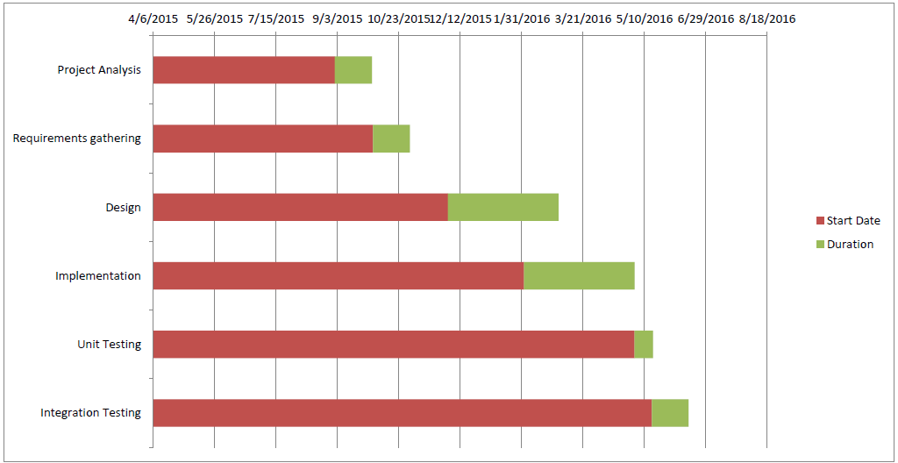

Figure : Gantt Chart

# Project Analysis

During the analysis phase of my project, I researched on the types of suits for men and different kinds of varieties they fall in. Following is the information I gathered during my research on this topic for my project with the help from my uncle’s on-going business.

The composition of a suit can be sub-divided into following shown components:

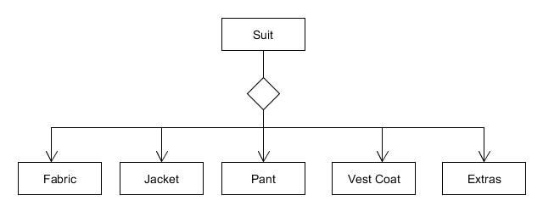

Figure : Domain diagram – Suit

Furthermore, looking into each individual sub-divisions of a suit, there are a lot of varieties and designs as follows:

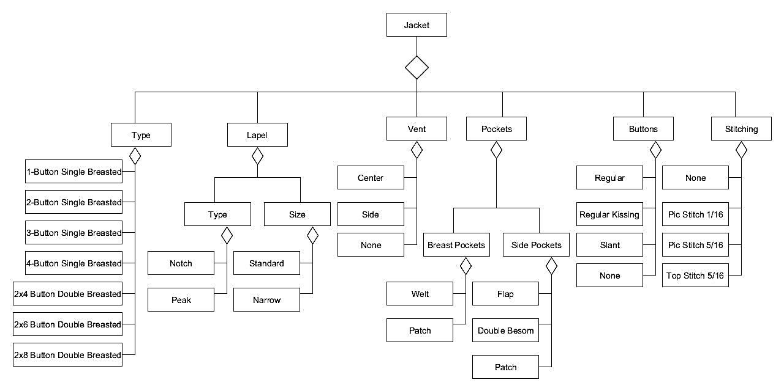

Figure : Domain diagram – Jacket

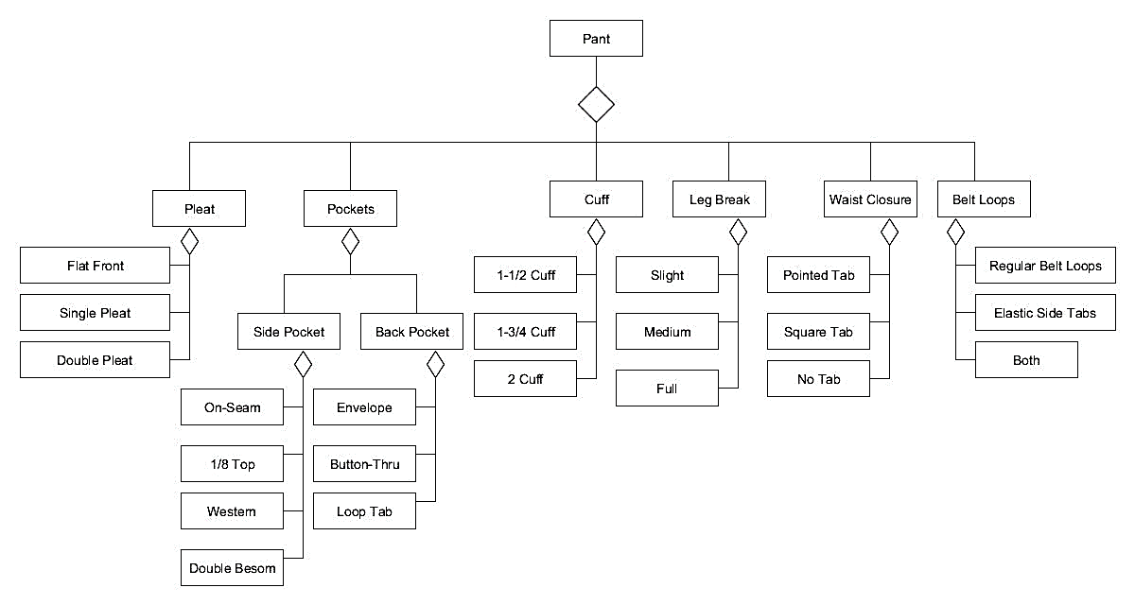

Figure : Domain diagram – Pant

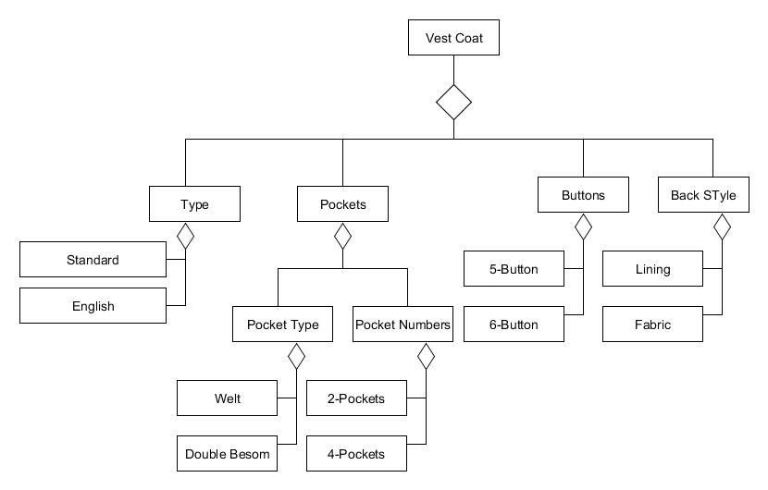

Figure : Domain diagram – Vest Coat

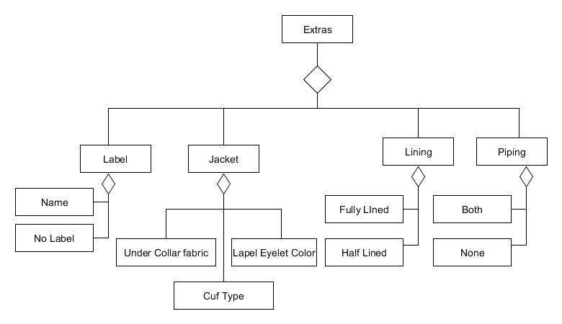

Figure : Domain diagram – Extras

These domain diagrams explain the sphere of knowledge and the entities used in the development of my project and are a key aspect of the requirements and the analysis phase.

# Project Design

Design of my system describes the architecture, the modules, and the approaches I have used in the development of my website. Design is developed keeping in view the requirements gathered by the user and it contains all the necessary diagrams including system state charts, use case diagrams, system activity diagrams, system sequence diagrams, entity relationship diagrams and class diagram.

## System Use Cases

Use case diagrams describe different interactions that take place between actors and the system for the achievement of a goal. In Figure 3 is the use case diagram that shows the different use cases and the actors who carry on the necessary interactions.

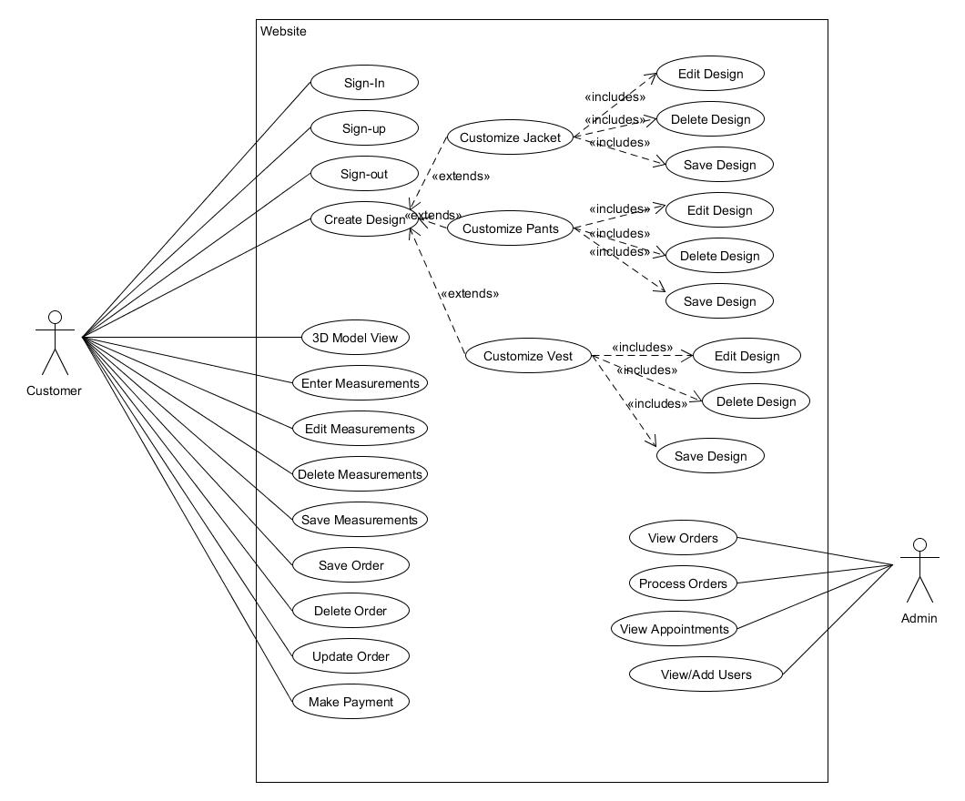

Figure use case diagram

## System Activity Diagram

The activity diagram in Figure 4 shows the flow of activity in my project, the decisions that are to be made during the actual execution of the project and the results that follow those decisions. A diamond shape in the figure represents decision making points.

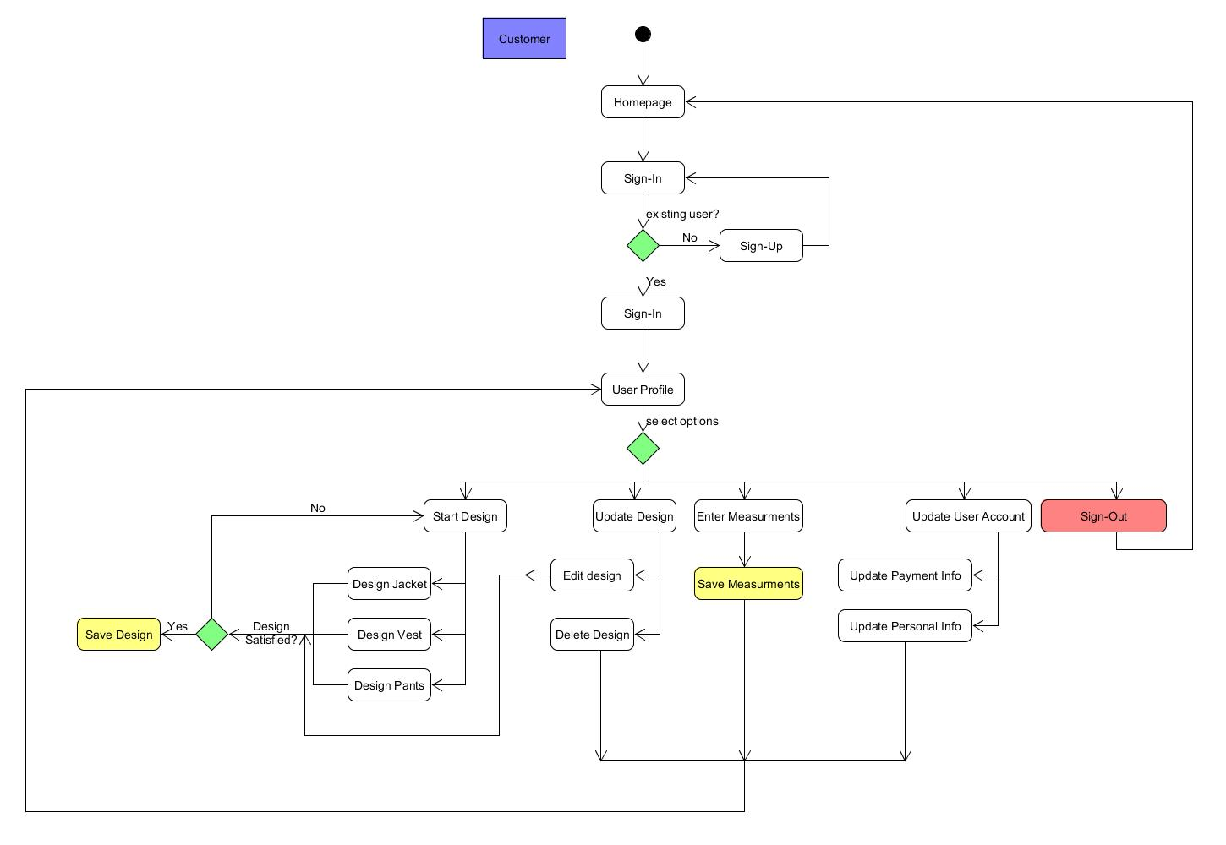

Figure : Activity diagram (Customer)

Shown in Figure 4 is the activity diagram of the Tool which represents the series of activities taking place during the execution from customer’s perspective

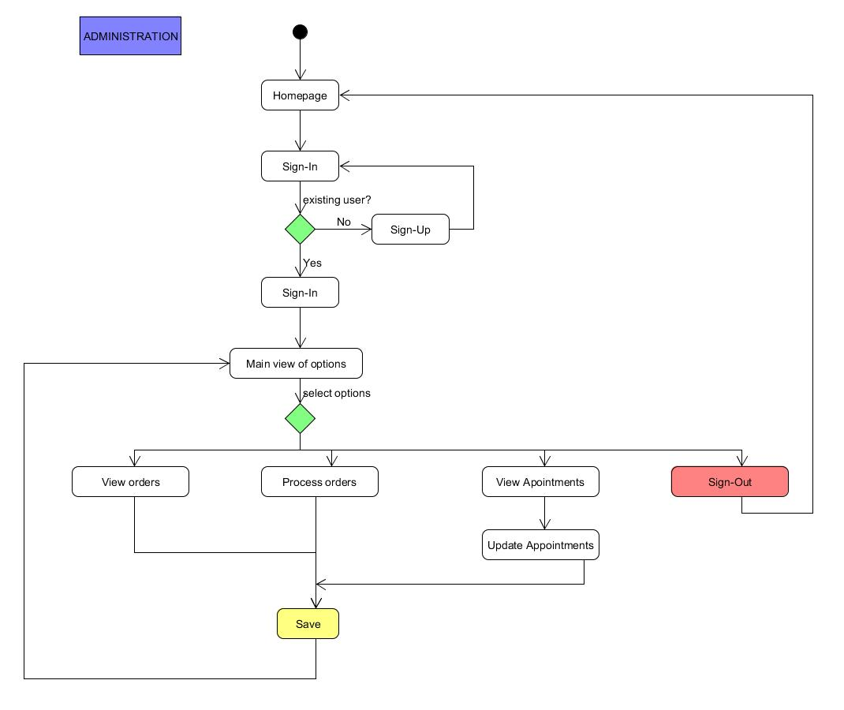

Figure : Activity Diagram (Administration)

Shown in Figure 5 is the activity diagram of the Tool which represents the series of activities taking place during the execution from administration’s perspective.

# Tools and Techniques

I have used various tools and techniques in my project; all of these techniques were applied and adapted after many research and analysis on these methods.

## My SQL

My SQL is a relational database management system. It is a server that provides access to several different users to a variety of databases created in the server. Furthermore, it is open source software that is easily available online under the general public license. I used SQL server to create the databases for user management and file management. I used these tables to save the information of every single user that has signed in and also to save all the details of the customer.

## Dreamweaver

Adobe Dreamweaver is a registered web development tool developed by Adobe Systems. I used this software for standard code development to develop my website using PHP, Bootstrap and JavaScript.

## PHP

PHP also known as Hypertext Preprocessor, is a server-side scripting language designed for web development. I used PHP embedded into HTML code to combine the results of the interpreted and executed PHP code including data or images with the generated webpage.

## Bootstrap

Bootstrap is a free and open-source front-end web framework for designing websites and web applications. It contains HTML- and CSS-based design templates for typography, forms, buttons, navigation and other interface components, as well as optional JavaScript extensions. Unlike many web frameworks, it concerns itself with front-end development only. I have used Bootstrap for the user interface and other features provided by it.

## HTML 5

I have used HTML 5 in my website, HTML is a hypertext markup language. HTML 5 is the latest version which has new elements, attributes and behaviors. It also has a larger set of technologies that allows more diverse and powerful websites and applications.

# Implemented Interface

The graphical user interface is designed keeping in mind the user-friendliness and aspects of HCI (Human computer interaction). The interface I used is simple yet understandable by the user. Feedback of important events taking place in the system is also kept in mind and the user is notified of such event. Moreover, my interface design is fault tolerant and allows the user to redo and edit whenever possible.

## My Wardrobe: Customer portal

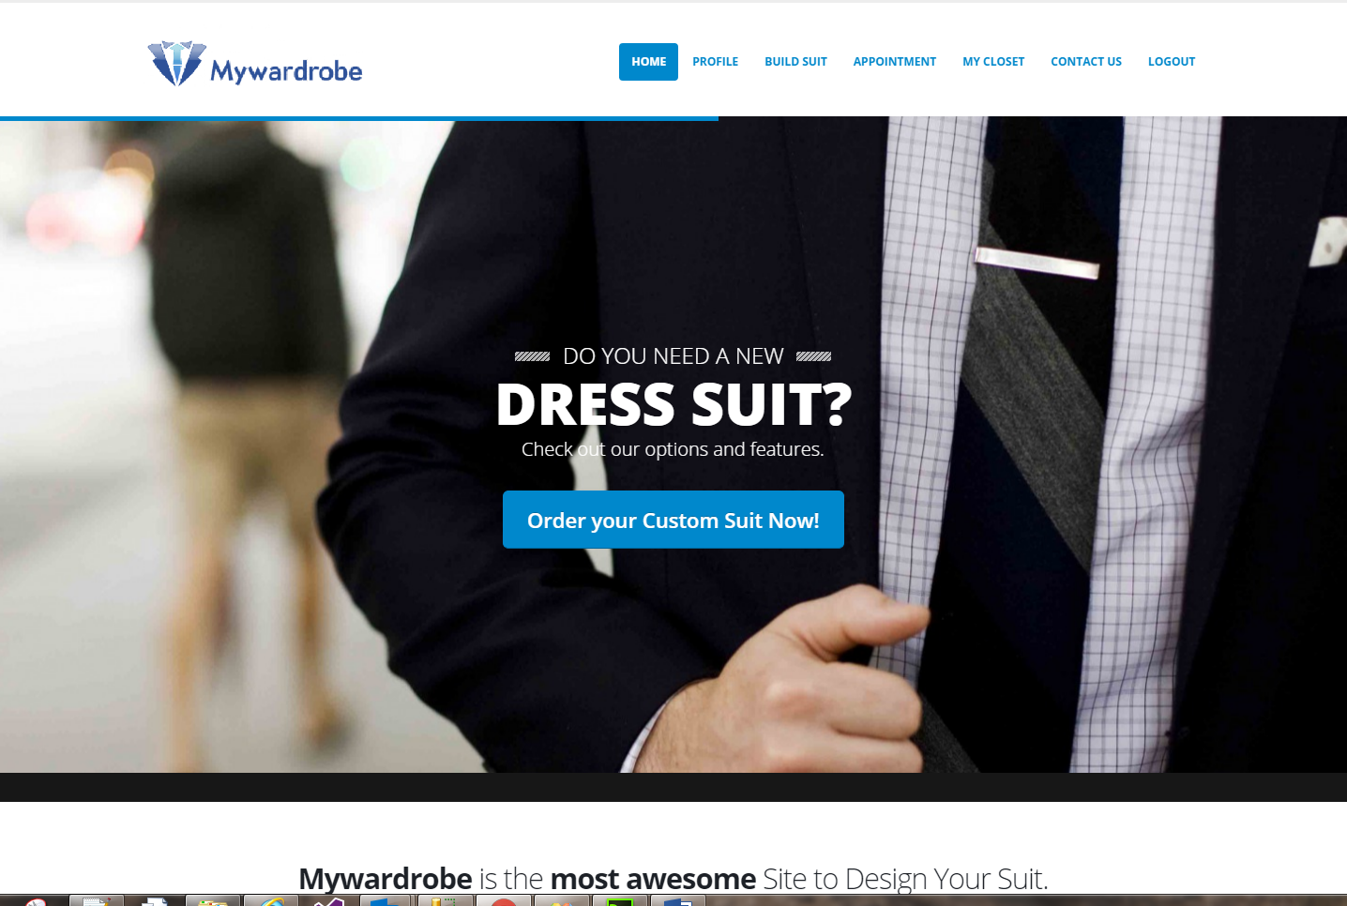

Figure : My Wardrobe- Homepage

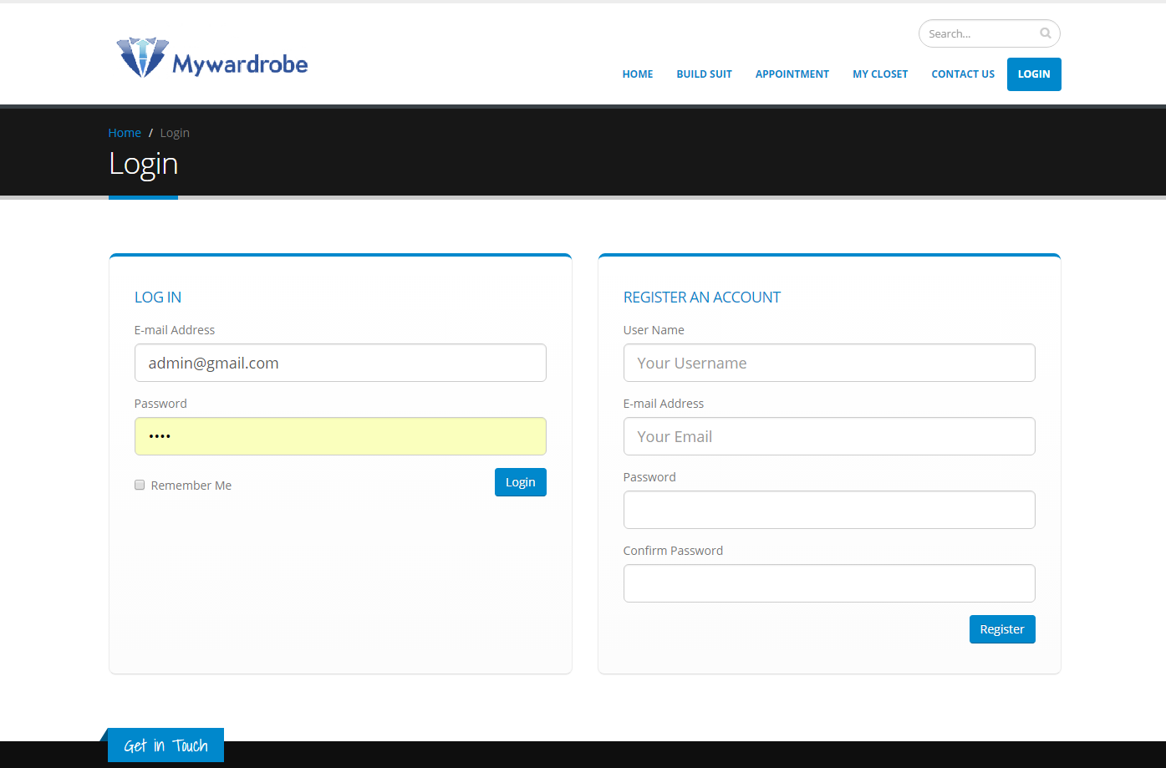

Figure : Sign In / Register page

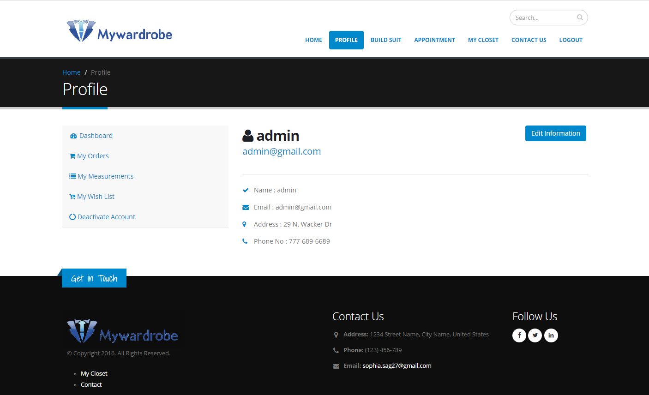

Figure : User Dashboard

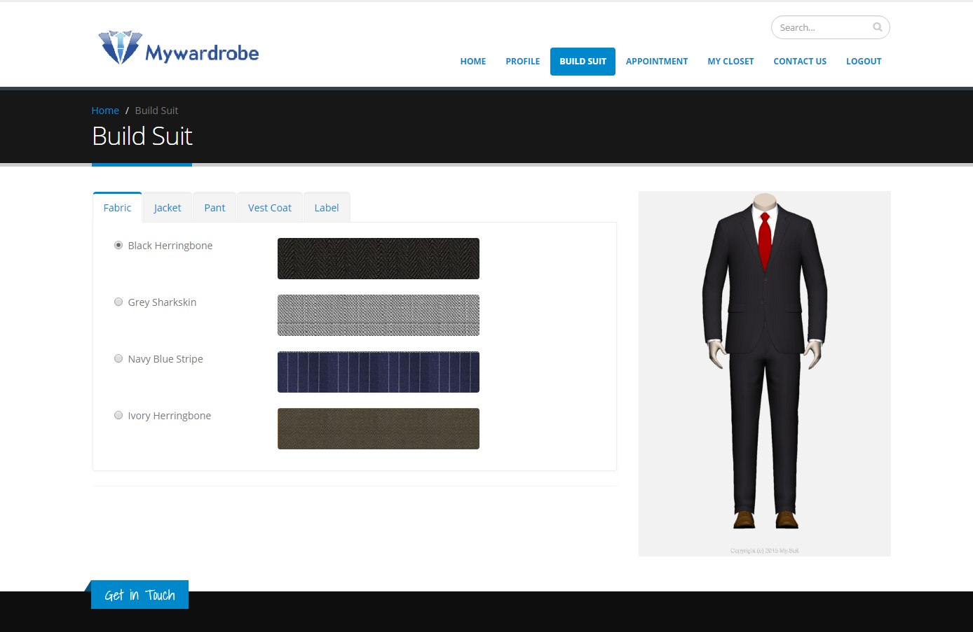

Figure : Build suit Page

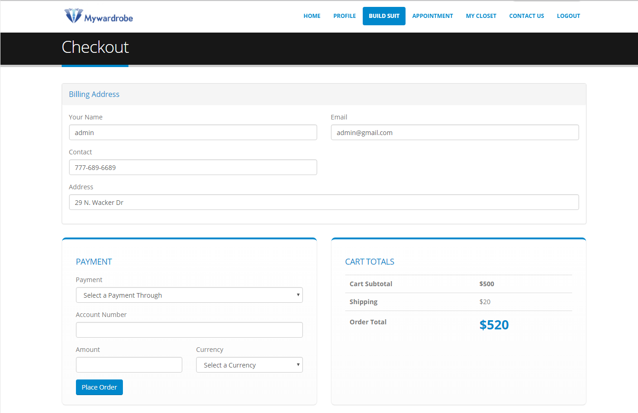

Figure : Checkout Page

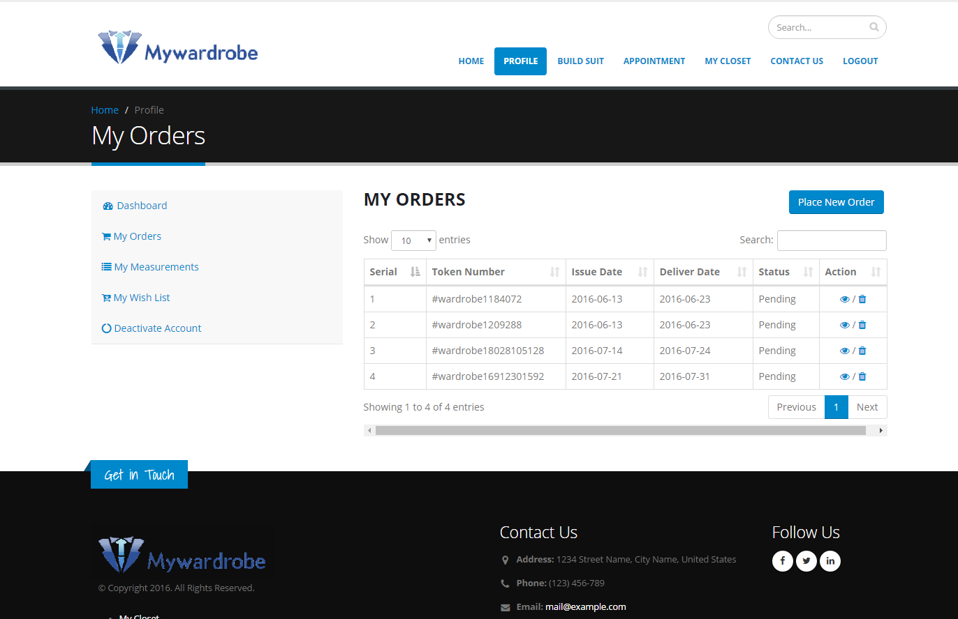

Figure : My Orders Page

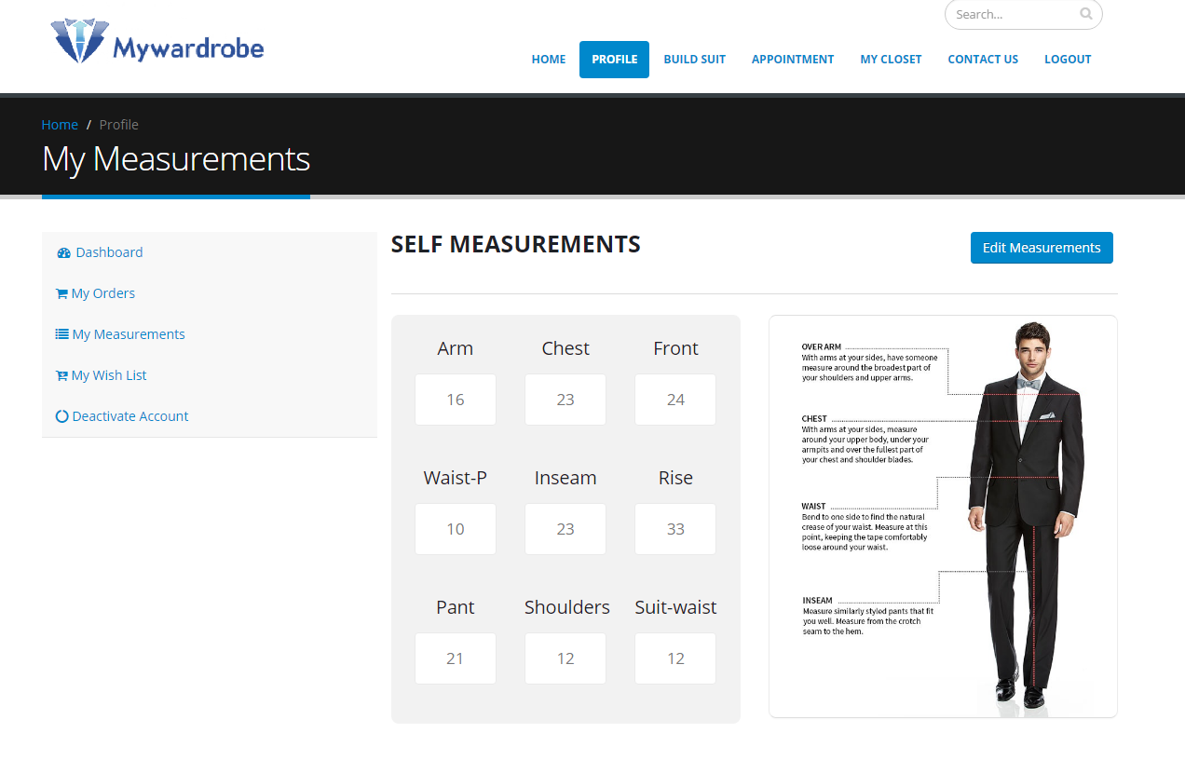

Figure : My Measurements Page

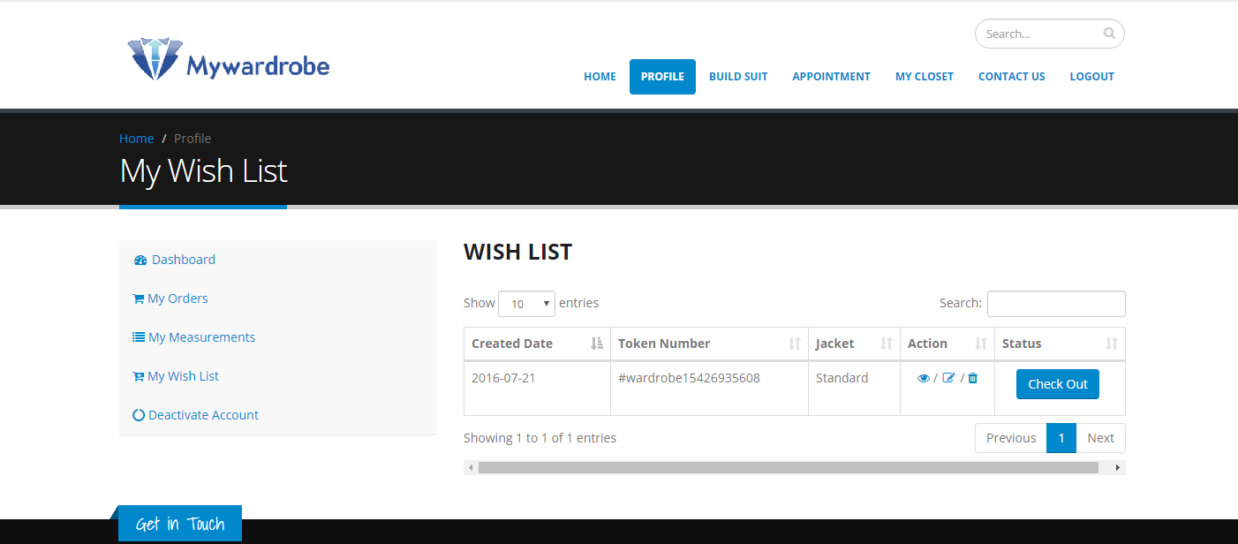

Figure : My Wish List Page

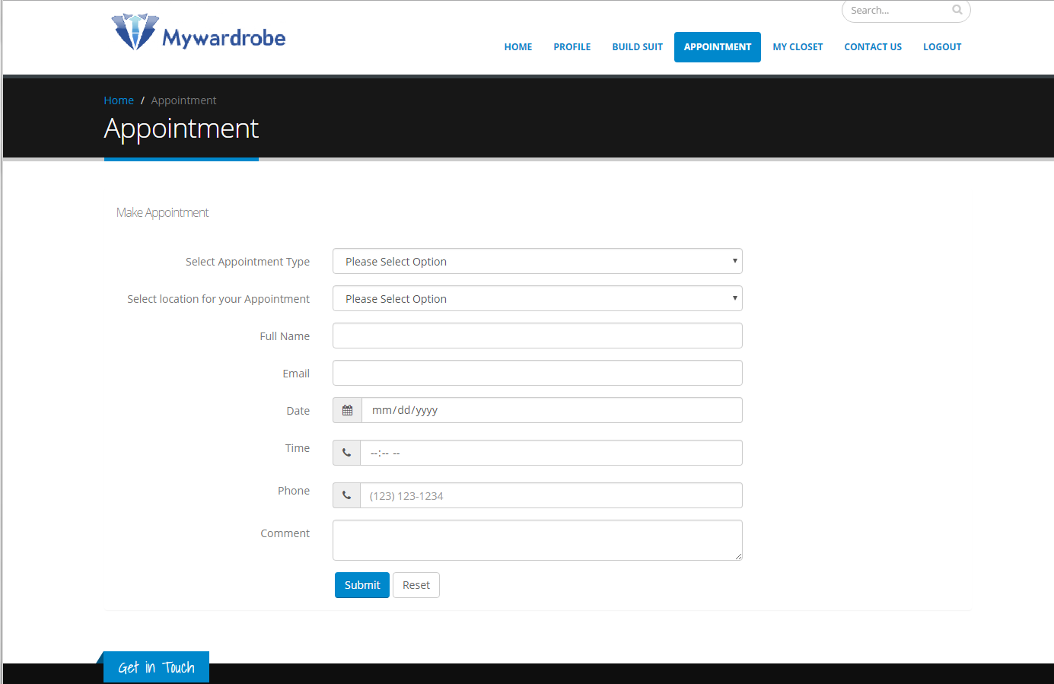

Figure : Appointment Page

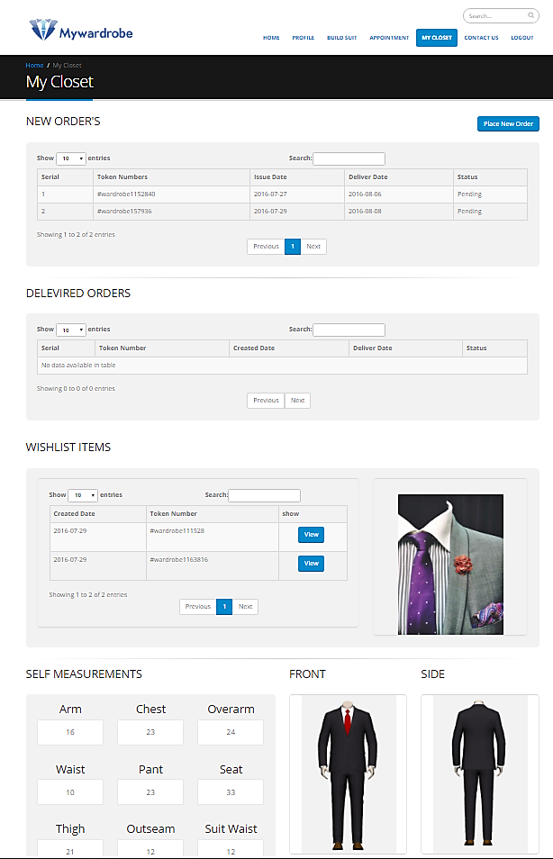

Figure : My Closet Page

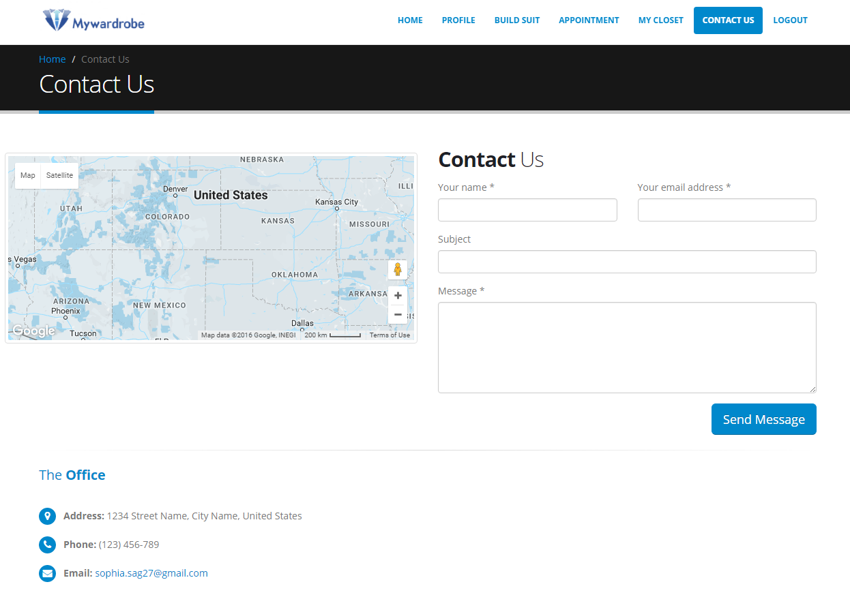

Figure : Contact Us Page

## My Wardrobe: Admin portal

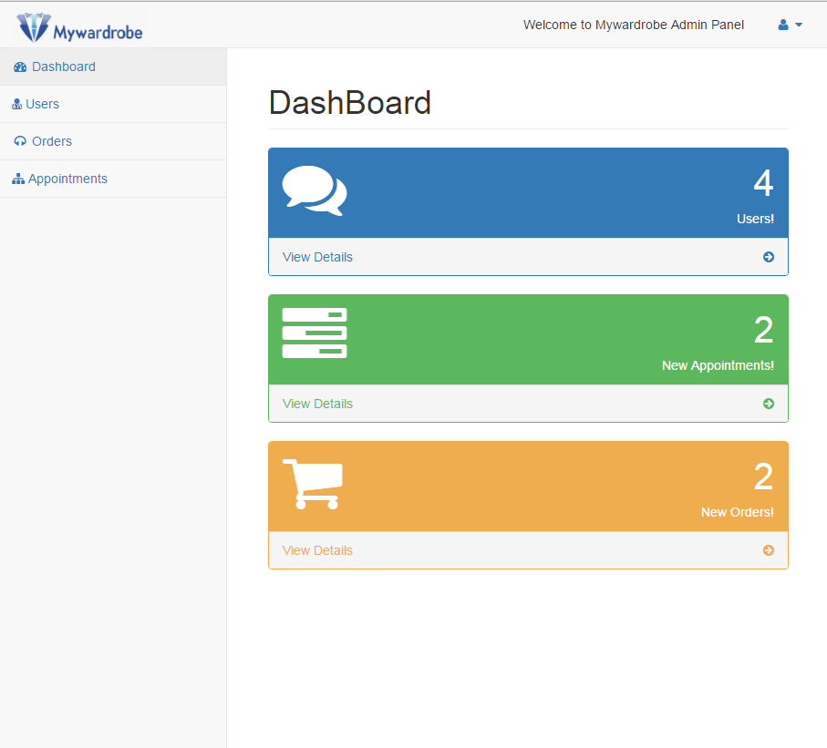

Figure : Admin Dashboard

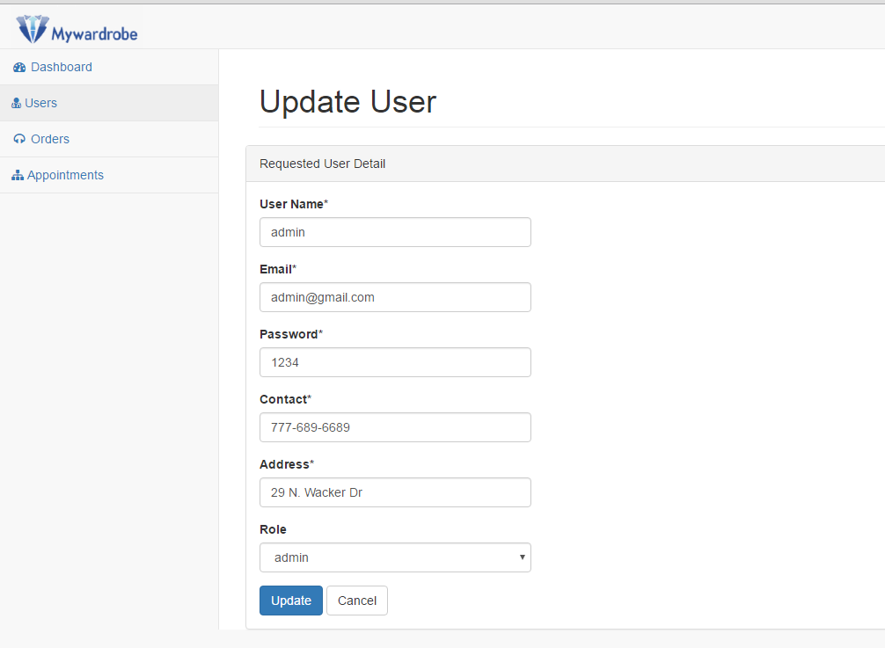

Figure : Admin- Update User

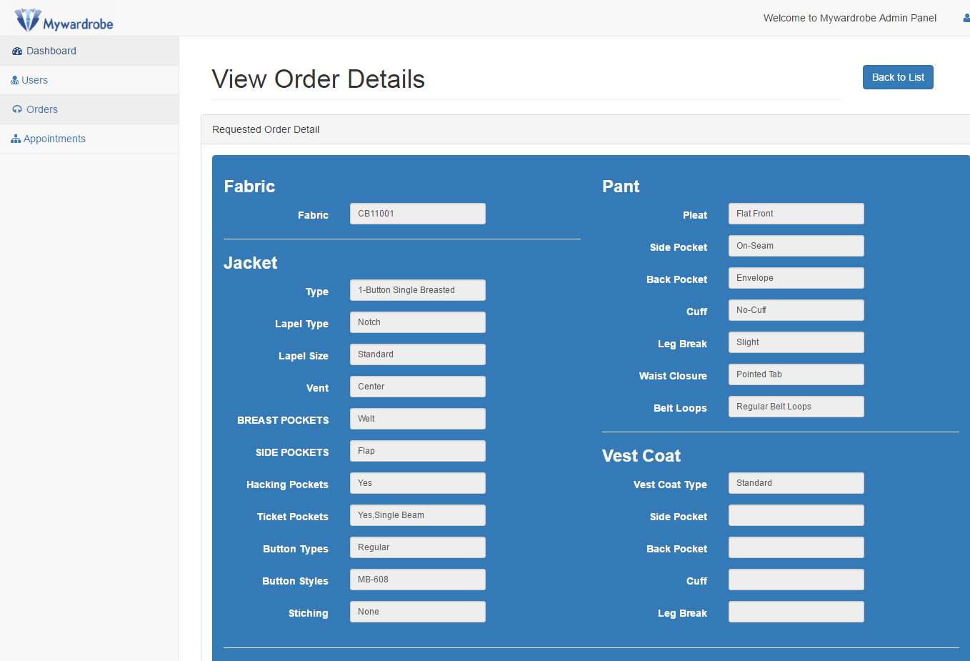

Figure : Admin- View Order Details

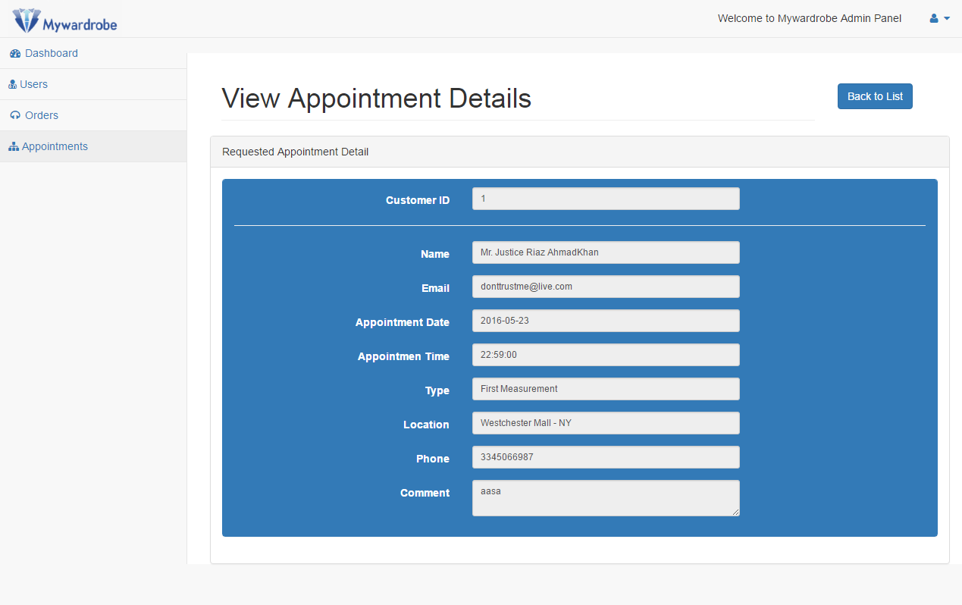

Figure : Admin- View Appointment Details

# Future Development

For future versions of the project more features can be added such as enabling a customer to have different measurements saved for other family members such as his/her children under the same profile.

All other features can be added to the next versions.

# Conclusions

The incremental software development approach followed by me during the project lifecycle enabled me to complete the project in the estimated time frame. During this project I learned many new technologies such as Bootstrap and how the framework has helped me create a neat and clean website.

The designed system satisfies the goals that were proposed. This project can be considered as a great opportunity for learning key concepts of PHP that helps the researcher to design and implement PHP based prototype application. By using this project, the research criteria to conduct an academic research can be learnt.

The website is user friendly, and I made sure that all the users may it be customers or administrator, would understand what they are doing guiding then through tooltips and warning messages throughout the website. User friendliness is an important aspect of a good website and I made sure that the users get a good experience getting their suits designed.

# References

[1] Bootstrap link: <https://github.com/twbs/bootstrap>

[2] Bootstrap CSS, link: <http://getbootstrap.com/css/>

[3] DataTables-Table plug-in for jQuery, link: <https://datatables.net/>

[4] Data Tables-Responsive,

[link: https://datatables.net/extensions/responsive/examples/styling/bootstrap.html](link:%20https://datatables.net/extensions/responsive/examples/styling/bootstrap.html)

[5] FONT AWESOME v.4.5.0, link: <http://fontawesome.bootstrapcheatsheets.com/>

[6] Google maps API, link: <https://developers.google.com/maps/documentation/javascript/>

[7] Men’s suits: a guide to modern suit styles, Daniel P Dykes,0 08 Dec 2010

Link: <http://www.fashionising.com/trends/b--mens-suit-styles-designs-modern-suits-1467.html>